Harbertonford Long Term Curriculum Map 2019-2021
 | Autumn |  | Spring |  | Summer
EYFS | Who’s who? | Carnival of colour | People who help us | Are we nearly there? | Once Upon a Time | Amazing animals
Hook or visit | Doctor visit  Lifeguard visit |  | Police visit with police car |  | Zoo (or similar)
Year 1&2  A | Fire! Fire!  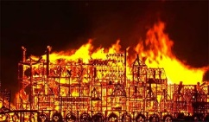 |  | Pirates and Privateers |  | Roots, Shoots & Muddy Boots
Hook or visit | Forest – burning houses |  | Pirate day  Golden Hind, Buckland Abbey |  | Dartington Deer Park
Year 1&2  B | Followers of Fashion |  | Wild Weather  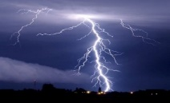 |  | Under the Sea
Hook or visit | Spinning wool  Local textiles mill |  | Hallsands (Forest and Beach) |  | Plymouth Aquarium
 | Science: Seasons, seasonal changes
Year 3&4  A | Dartmoor Rocks!  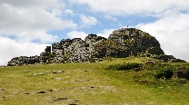 |  | Eruptions and Explosions  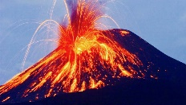 |  | Greece is the Word
Hook or visit | Haytor, Dartmoor |  | Forest school – erupting volcanoes! |  | Residential
Year 3&4  B | What did the Romans ever do for me?  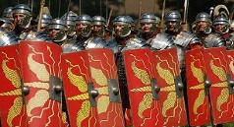 |  | Raging rivers  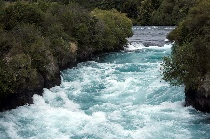 |  | Walk Like an Egyptian
Hook or visit | Roman Day |  | SW Water visit  River Dart & Palmer’s Dam |  | Exeter RAMM
Year 5&6  A | World at War |  | Out of this World |  | Chocolate
Hook or visit | Air raid siren procedure South Devon Railway |  | STEM centre Space workshops – Plymouth |  | Make our own chocolate South Devon Chilli Farm
Year 5&6  B | Invincible Invaders  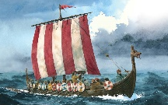 |  | You are what you eat |  | Victorian Revolution  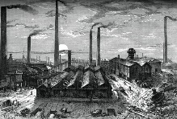
Hook or visit | RAMM museum – Exeter |  | Cook a healthy class meal  Sporting Event/meet an athlete |  | Morwelham Quay

